11 11 Physical Therapy, LLC

Personal Information:

Last Name: | First Name: M.I. Gender
Address:
City: | State: Zip:
Date of Birth: | Email:
Cell Phone: | Work Phone:
Insurance: | ID# Grp#

Insured/Responsibility Party (Leave blank if same as above):

Last Name: | First Name: M.I.
Address:
City: | State: Zip:
Date of Birth:
Cell Phone: | Work Phone:
Relationship to patient:

Emergency Contact Information:

Last Name: | First Name:
Relationship to patient:
Cell Phone:

Other Information:

Referring MD: | PCP:

Date of Injury/Symptoms Onset: | Check One: Surgery (Date: ) Auto Work Related Fall Other
Description of Symptoms:

Current Medications with Dosage and Frequency:

Signature of Patient or Guardian (if patient is a minor):
Date:

11 11 Physical Therapy, LLC
Pain Diagram:

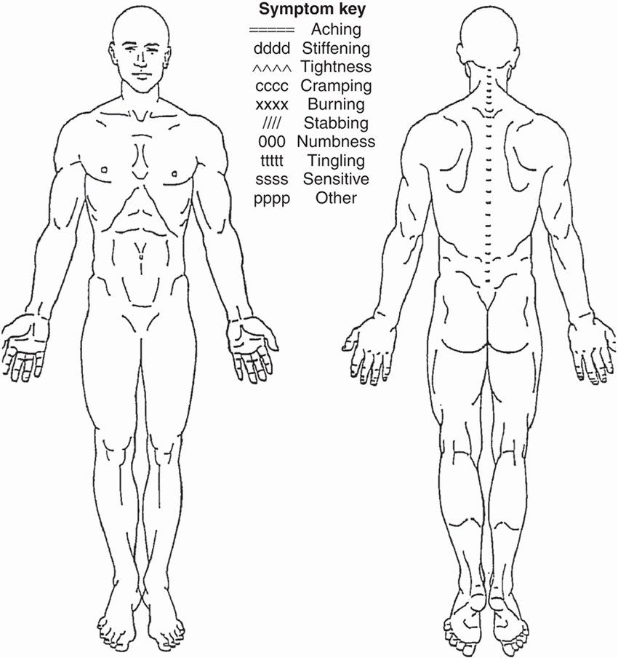
On a scale from 0-10 (0 is no pain, 10 is emergency room pain):
Rate your Pain at its least over the past month:
Rate your Pain at its worst over the past month:
Rate your Pain at its currently:

Name:
11 11 Physical Therapy, LLC
Medical History:

Name: | Height: | Weight:
Prior Surgeries w/Date:
Recent Diagnostic Tests (MRI, CT Scan, X-Rays, Ultrasound, Bone Scan, EMG/NCV Test):

Prior Treatments (PT, Acupuncture, Chiropracty, etc.):
Have you had any falls this past year? | Yes if so, date(s): | No
Check if you have or have had any of the following conditions:
Alcohol Abuse Angina Anxiety/Panic Disorders Arthritis (OA, RA) Autoimmune Diseases Asthma COPD CHF Degenerative Disc Disease Depression Diabetes (Type I, Type II)
Drug Dependency Hearing Impairment (hearing aids, tinnitus, deafness) Heart Attack
Multiple Sclerosis Osteoporosis Parkinson’s Disease Peripheral Vascular Disease Stroke or TIA Upper Gastrointestinal Disease (ulcer, hernia, reflux) Visual Impairment (cataracts, glaucoma, macular degeneration) Allergies Headaches Bleeding Disorders Bowel/Bladder Abnormalities Cancer Dizziness/Vertigo Epilepsy Seizures Fracture Hepatitis A, B, C Hernia High Blood Pressure Hypoglycemia Immunosuppressant Condition or Medication Kidney Problems Liver/gall bladder Problems Metal Implants Nausea/Vomiting Pacemaker/Defibrillator Pregnancy Sexual Dysfunction Skin Abnormalities Smoker Special Diet Guidelines Other Diseases:

Signature: Date:
11 11 Physical Therapy, LLC
Patient Authorization

Release of Information and Consent for Treatment:

I wish to receive treatment at 11-11 Physical Therapy, LLC and permit its employees and all other persons caring for me to treat me in ways that are beneficial to me. I understand that this care can include an evaluation, testing and treatment. No guarantees have been made to me about the outcome of this care.
Initial:_____

I give permission to 11-11 Physical Therapy, LLC to release information, verbal, electronic and written, contained in my medical record and other related information, to my insurance company case manager, employer, related healthcare provider, assignees and/or beneficiaries and all other persons as it relates to my treatment or payment provided.

Initial:_____

I authorize 11-11 Physical Therapy, LLC to obtain medical records and/or medical information from my physician or other medical professionals as it relates to my treatment.
Initial:_____
Assignment of Benefits:

I authorize payment directly to 11-11 Physical Therapy, LLC for services and to bill and release payment directly to 11-11 Physical Therapy, LLC for any physical therapy services provided. This is a direct assignment of my rights and benefits under this policy. A photocopy of this assignment shall be considered as effective and valid as the original.
Initial:____
Cancellation Policy:

Due to high patient demand and the limited availability of appointments, 11-11 Physical Therapy has instituted a “No Show and Late Cancellation Fee” of $70. It is important that if you wish to cancel or reschedule an appointment that we receive at least 24 business hours notice so that we can call and schedule patients from our waiting list.
Initial:_____
Payment:

I agree to pay 11-11 Physical Therapy, LLC for the services provided to me or the related party being treated. If any law, such as workers’ compensation, or insurance contract prohibits payment for these services, I will cooperate and assist in the provisions of information, authorizations, releases, or any other type of information necessary to allow for the speedy collection from my third party payer. Where the law or an insurance contract does not prohibit payment by me, I acknowledge responsibility for any and all account balances. Benefit verification obtained from my insurance company in not a guarantee of coverage. If the information provided by my insurance company is not accurate or the insurance company changes its coverage, I will be responsible for payment for services.
Initial:_____
I further understand that this agreement is binding regardless of any legal transition currently in progress or initiated during or after the course of my treatments unless agreed to in writing by myself and a representative of 11-11 Physical Therapy, LLC.
Initial:_____

Notice of Privacy Practices (HIPPA Acknowledgement/ Consent)

I hereby acknowledge that I have received a copy of the Notice of Private Practices for 11-11 Physical Therapy, LLC. In addition, I hereby consent to the use and disclosure of my personal health information for the purposes of treatment, payment and healthcare management/operations.
Initial:_____

The signature below certifies that I have read and understand the above information.

Patient or Guardian Signature:________________________________Date:____________

